Don’t miss this!

Parenting Week

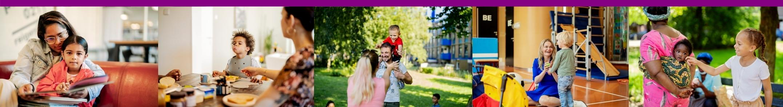

Free, fun parenting meeting:
Our life puzzle

A positive, strong, and healthy approach to life and parenting
Raising children is fun, but it can also be challenging and energy-consuming. How do you take good care of yourself as a parent and how can you set a good example for your children?

For whom?
This workshop is for parents with children aged 0-18 (parents only).
Workshop time and location:
October 14, 2025, from 10:00 AM to 12:00 PM at Bijlmerdreef 1134, 1103JT Bijlmeroost

What will we discuss?
- Discussing the most important life goals
- Finding a balance between (work), parenting, and relaxation
- Sharing experiences and learning from each other's strengths
- Topics discussed include: nutrition, exercise, relaxation, social interaction, and so on.
- Enjoy delicious snacks

Registration required!
How to register:
By email: bijlmeroost@oktamsterdam.nl
By phone: Bianca Odenthal +31 642931795
Thirza Beaumont +31 62025868

